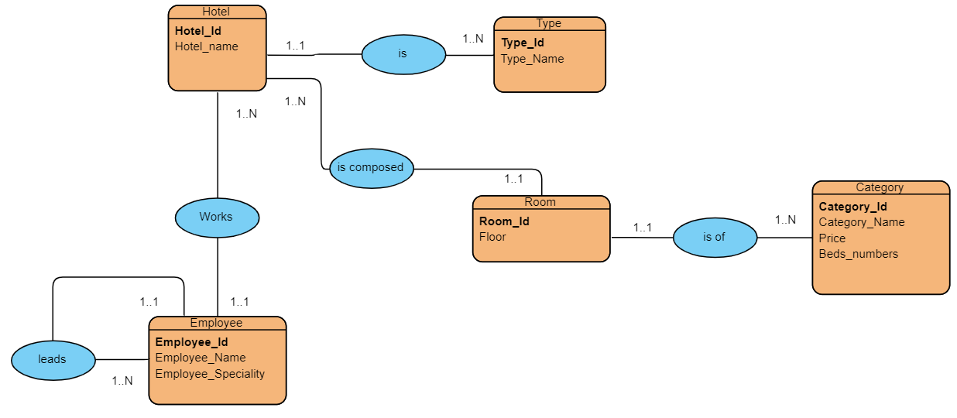
Convert the entity relationship model to a relational diagram

Réponse
- Hôtel (Hotel_id, Hotel_Name, #Type_id)
- Type(Type id, Type_Name)
- Employee(Employee_id, Employee_Name, Employee_Speciality, #Hotel_id , #chefHotel_id)
- Room(Room_id, floor, #hotel_id, #category_id)
- Category(Category_id , Category_Name , Price, Beds_Number)

